Introduction to AI
Table of Contents
Part 1: Classification 2
Part 2: Regression 3

Part 1: Classification
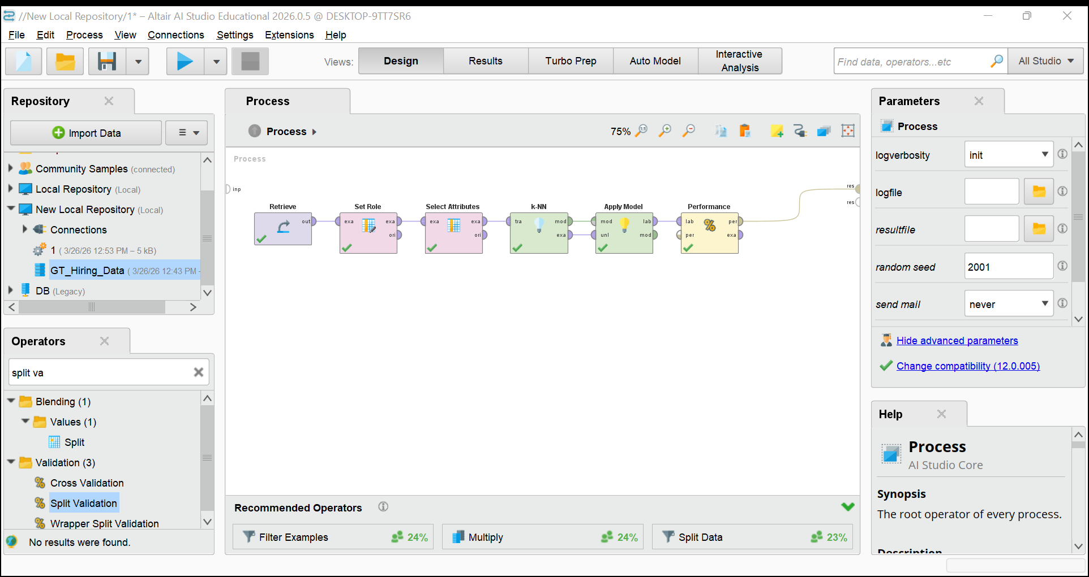
Figure 1: AI Studio process design
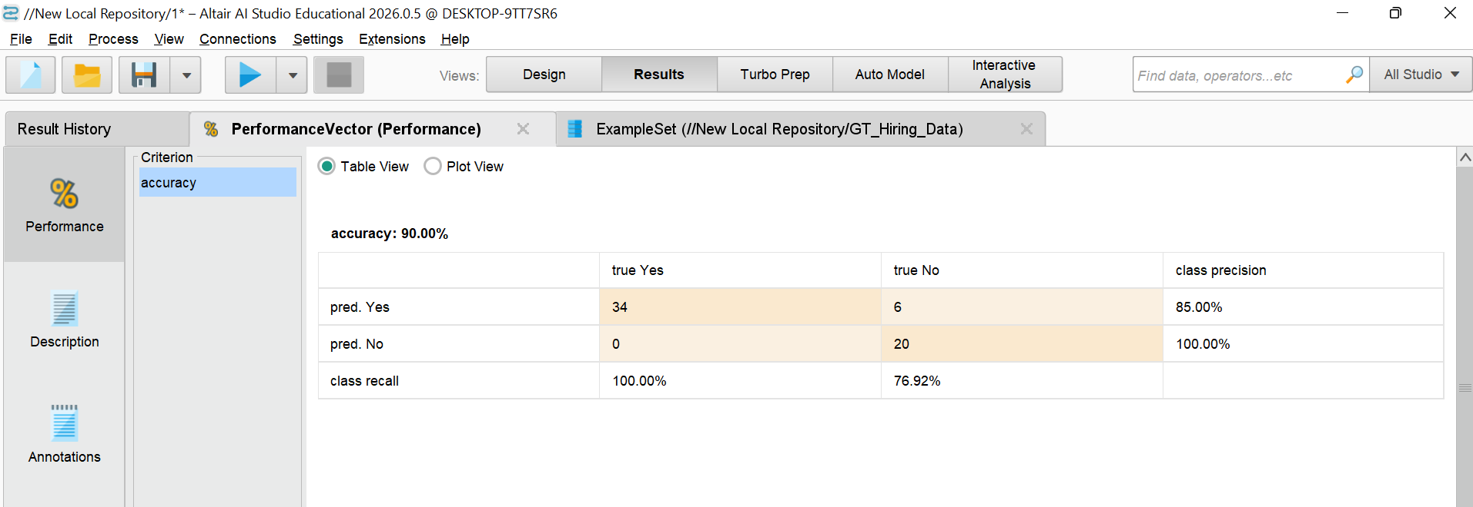
Figure 2: Performance vector

Part 2: Regression
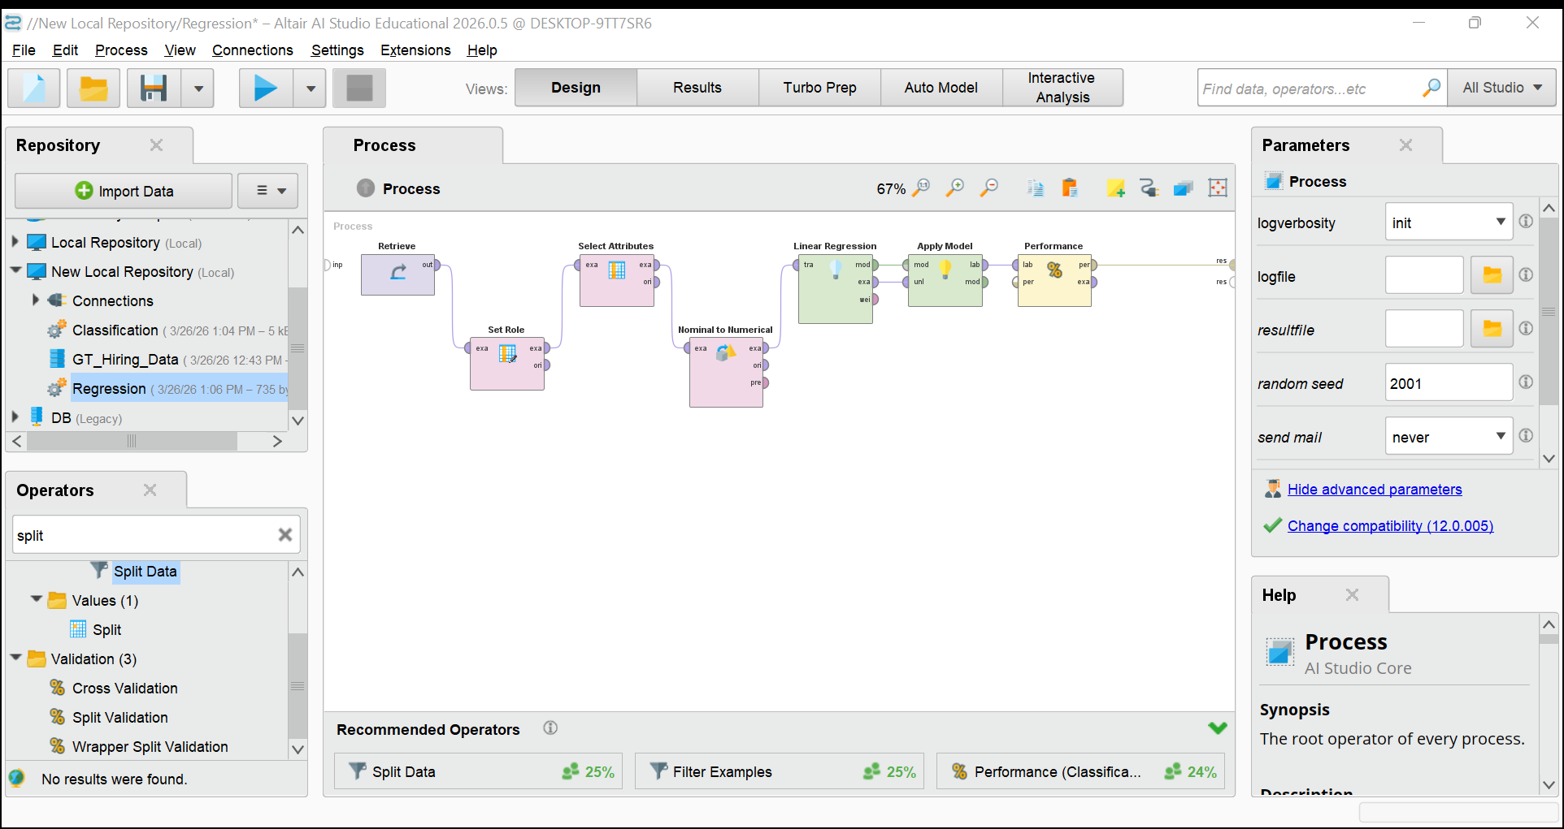
Figure 3: AI Studio process design
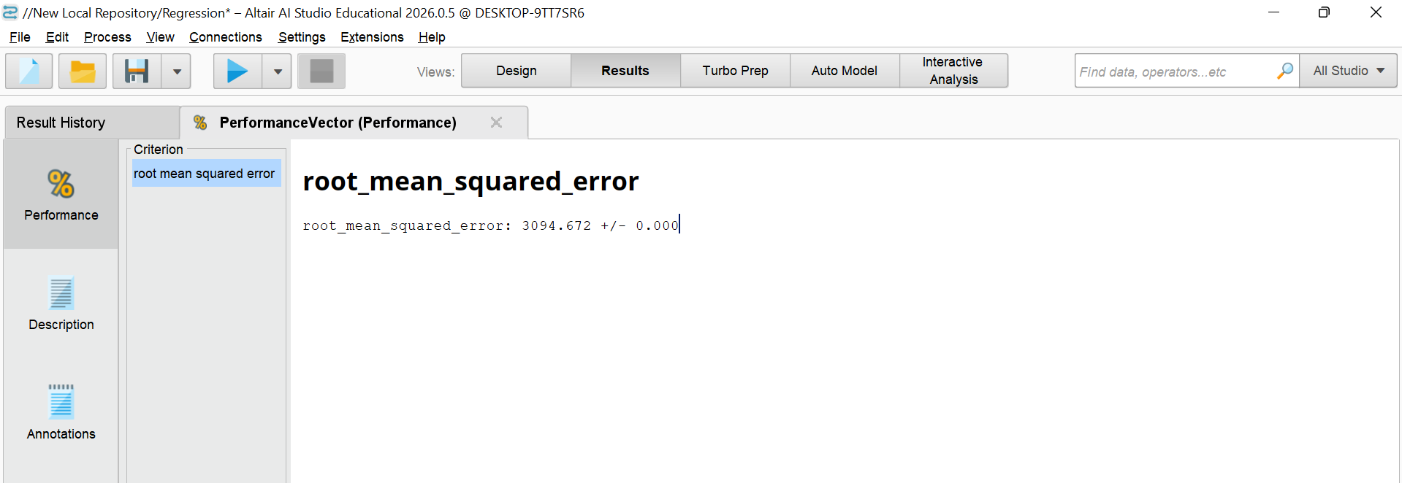
Figure 4: Performance vector

